GITAM

(DEEMED TO BE UNIVERSITY)

TITLE:PCB WORKSHOP

SUB TITLE :ANALOG AND DIGITAL

ECE DEPARTMENT

TEAM MEMBERS

NAMES:

D. Anil Kumar (BU21EECE0100109)

Piyush Kumar (BU21EECE0100207 )

Jamih (BU21EECE0100484)

PCB WORKSHOP

DIGITAL CIRCUIT

Simulation of 3\*8 Decoder:

Components Required:

1.Bread board-1

2.Resistors

3.Power Supply

4.Connecting Wires

5.74HC11-3(AND GATE)

6.74HC04-1(NOT GATE)

7.LED

CIRCUIT DIAGRAM:

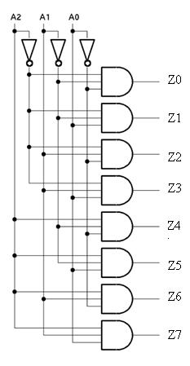

TRUTH TABLE:

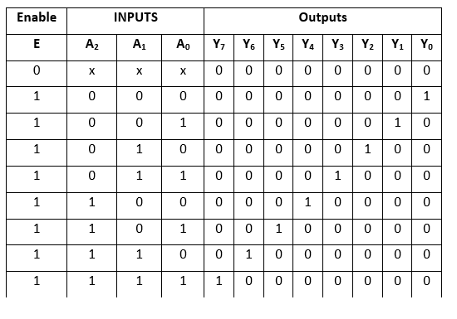

Circuit Schematic in Tinkercad:

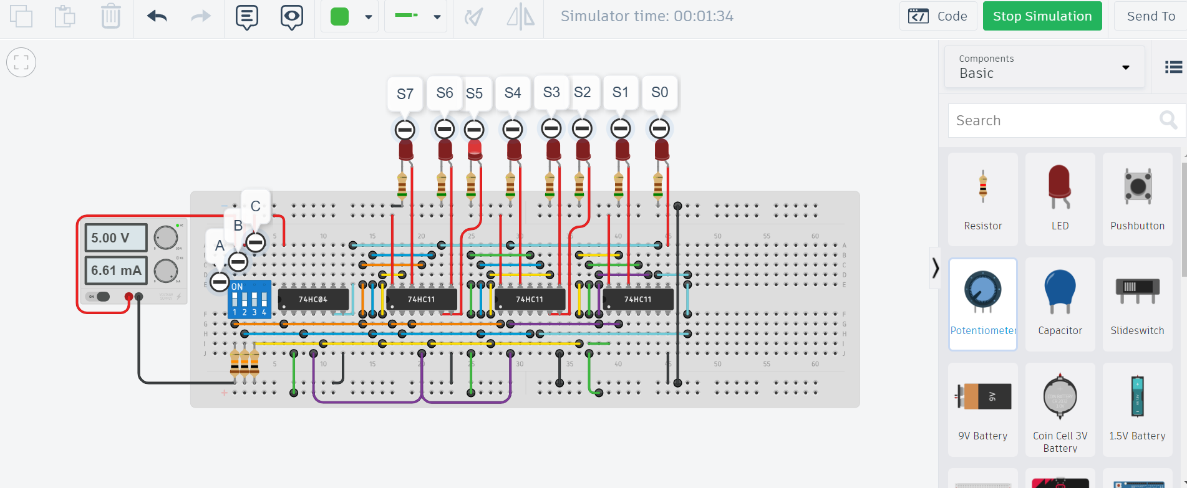

PROCEDURE:

1.Connect the Circuit as shown as figure.

2.Connect the Power supply to the bread board.

3.Connect the LEDs.

4.Start the Simulation.

5.By the Truth table the following LEDs glow accordingly.

Result:

Hence Implementation of 3\*8 decoder is done